ADSD HW2 Install Github/Tools

I have initial my github, and deploy to-do list on pythonanywhere.

Github repo: https://github.com/changcode/ADSD_TODO

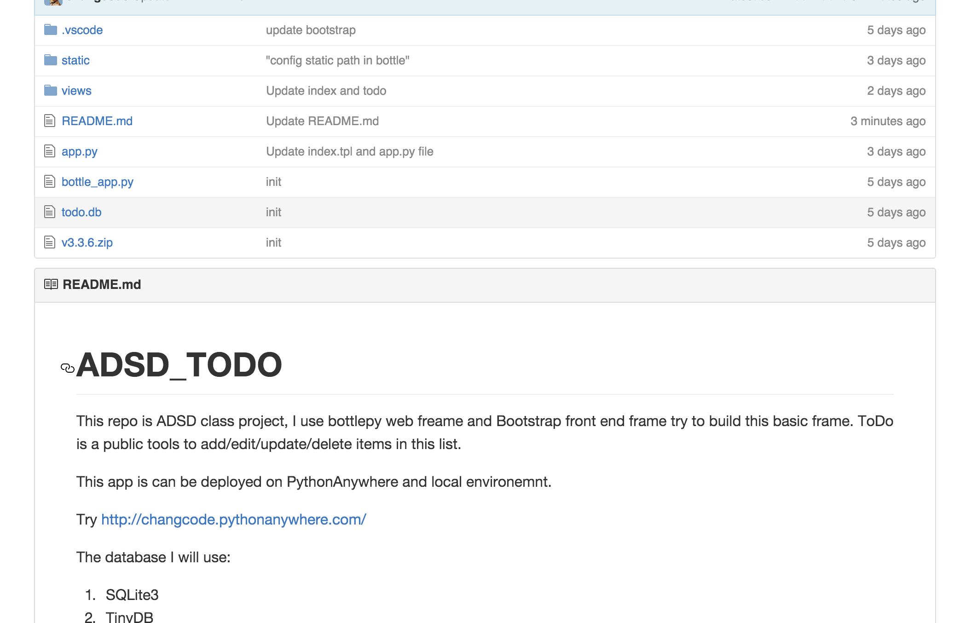

Pythonanywhere: <http://changcode.pythonanywhere.com/todo>

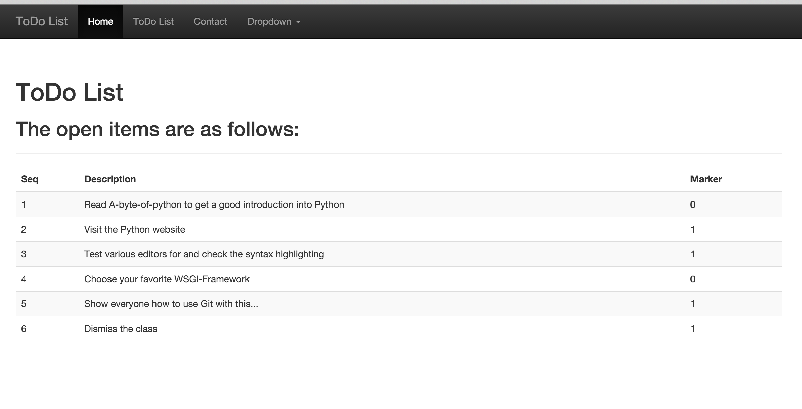

LocalEnvironemnt:

I use PyCharm IDE to do development, it’s awesome IDE in intellij products.

